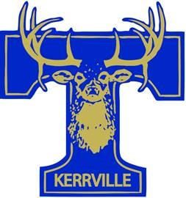
Tivy Summer Band Dates
Fall 2021

The following is our Spring/Summer Marching Rehearsal Calendar. All rehearsals will be held at the Tivy Bandhall. Please plan accordingly so there are minimal conflicts with out of town trips, etc. Water, athletic shorts, t-shirts, and tennis shoes are required for rehearsals. During the summer, adequate sunscreen and hats are needed. Fun Fridays will happen in May, and will be to introduce the incoming freshmen to marching skills and techniques. These required by the freshmen and the leadership team. We look forward to getting started on another successful marching season!
May 7, 14, 21 | Fun Fridays (Incoming Freshmen and Leadership) | 4:00 PM – 6:00 PM
June 1 – 3 | Everyone Music Camp (Lunch noon) | 9:00 AM – 3:00 PM
July 12 – 16 | Percussion and Guard Camp (Lunch noon) | 9:00 AM – 3:30 PM
July 19-20 | Leadership Camp (Lunch noon) | 9:00 AM – 4:00 PM
July 21 | Incoming New Members & Leaders Only  (Lunch noon) | 8:00 AM – 4:30 PM
July 22-23 | Everyone Band Camp (Lunch noon) | 8:00 AM – 4:30 PM
July 26 - 30 | Everyone Band Camp (Lunch noon) | 8:00 AM – 4:30 PM
August 2 – 6 | Everyone Band Camp (Lunch noon) | 8:00 AM – 4:30 PM
August 9 -13 | Everyone Band Camp (Evenings) | 5:00 PM – 7:00 PM
August 12 (TENTATIVE) | “Meet the Tivy Band” Night | 6:30 PM

Contact Us:
Roxanne Vickers, Head Director – roxanne.vickers@kerrvilleisd.net x3619
Tyler McClendon, Assistant/Percussion Director – tyler.mcclendon@kerrvilleisd.net x3703

